Graphic Processing

Lungoci Luca

Gr. 30434



Content

1. Subject specification

2. Scenario

Scene and object description

Functionalities

3. Implementation details

a. Functions and special algorithms

Possible solutions

The motivation of the chosen approach

b. Graphics model

c. Data structures

d. Class hierarchy

4. User manual

5. Conclusions and further developments

6. References

2) Subject specification

OpenGL is considered an Application Programming Interface (API) and is used to develop graphical applications by accessing features available in the graphics hardware. However, OpenGL is a specification developed and maintained by the Khronos Group. The OpenGL specification describes what is the desired result or output of each function. The actual implementation can be different between various OpenGL libraries. These libraries are implemented mainly by the graphics card manufacturers.

From this project I learned how work with OpenGL and to create something similar to a video game. I learned what happens behind the scenes when a user moves through a scene, looks around, how it is done to recreate shadows and light in a virtual world and many others.

3) Scenario

For my project, I wanted to create a scene resembling a forest. Objects of the scene include trees, a dog, a campfire with a tent. To improve the aspect of the scene, a skybox with a wild landscape is wrapped around the map. Fog can be noticed covering the scene.

Functionalities

The user is able to move around the scene, to look in different directions using the keyboard and mouse.

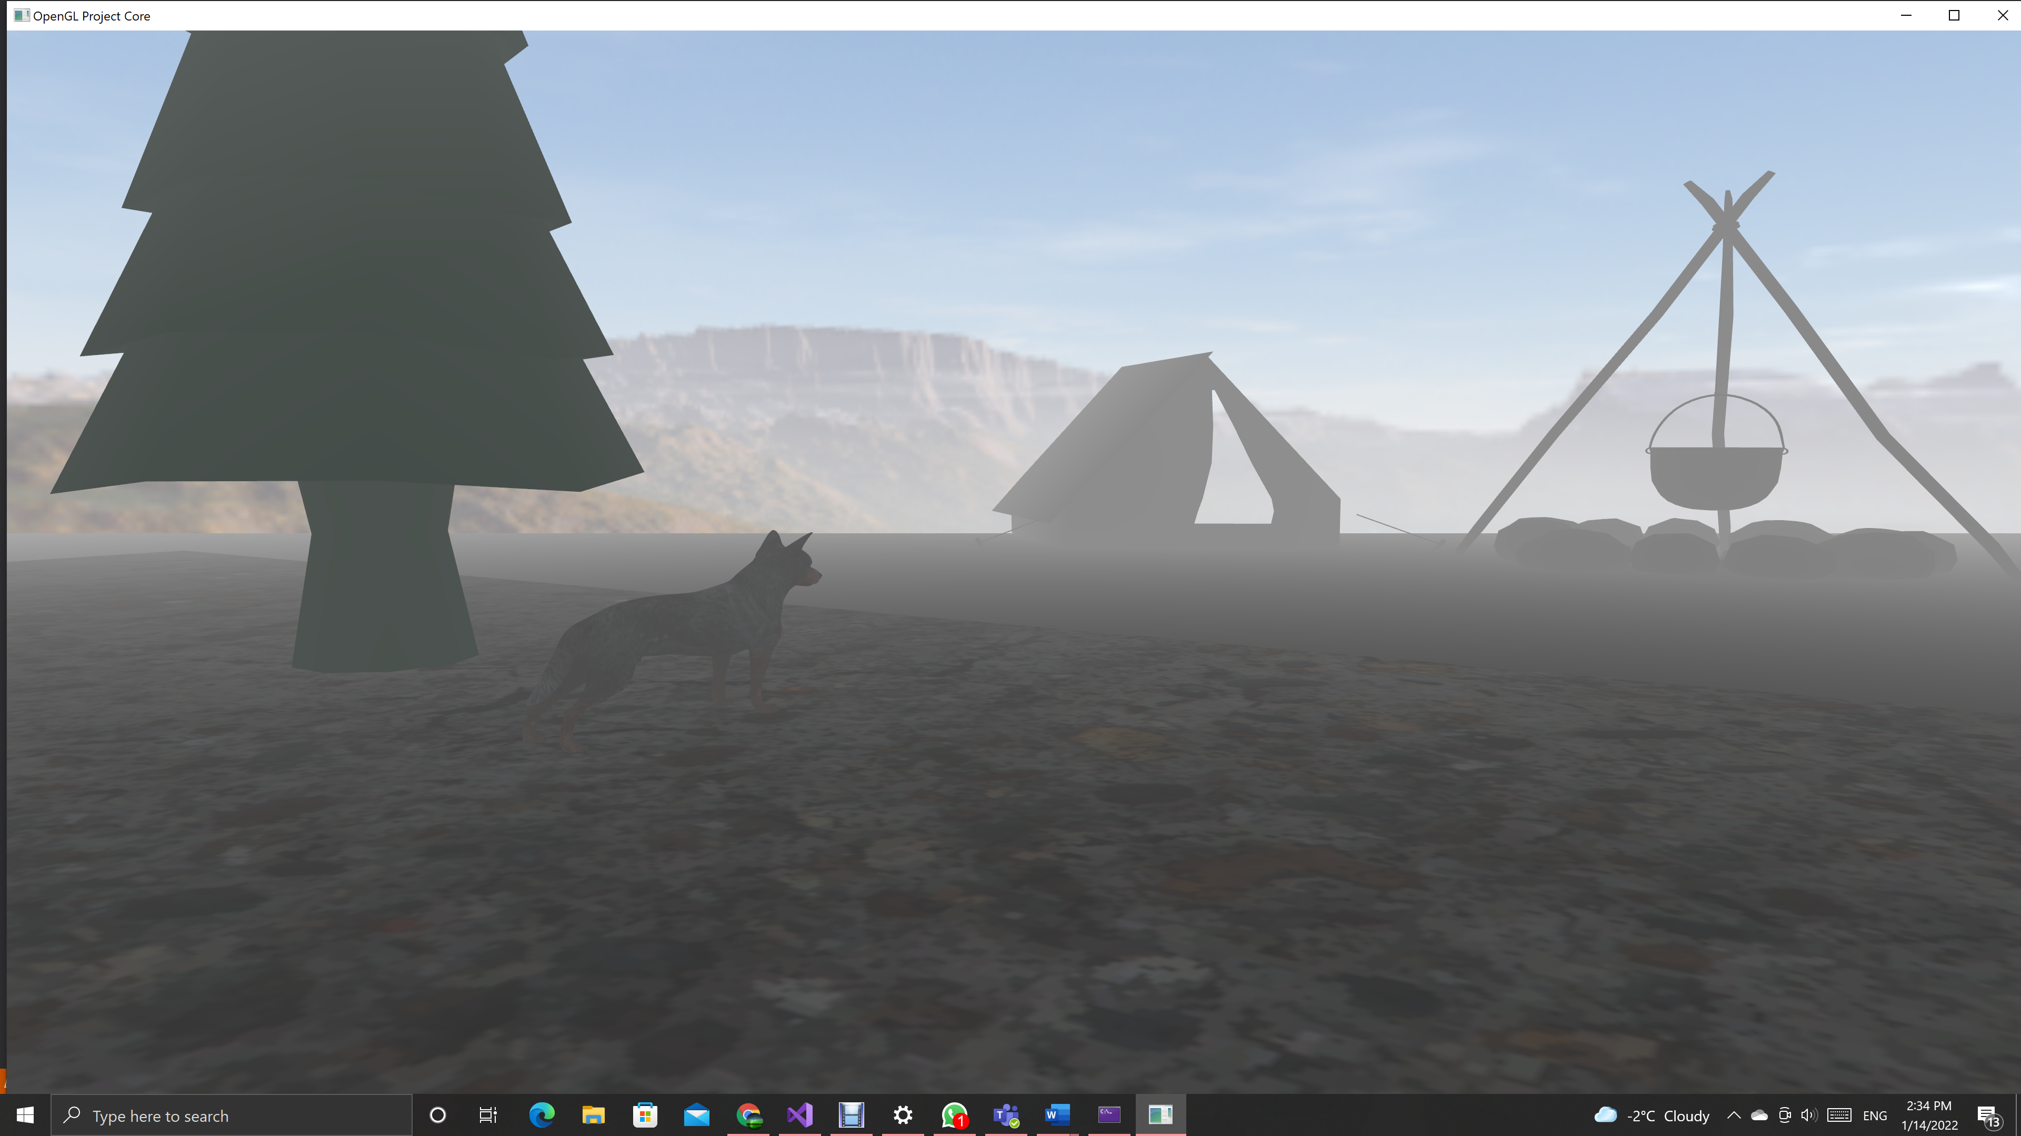

The result of a point light can be seen on the nanosuit.

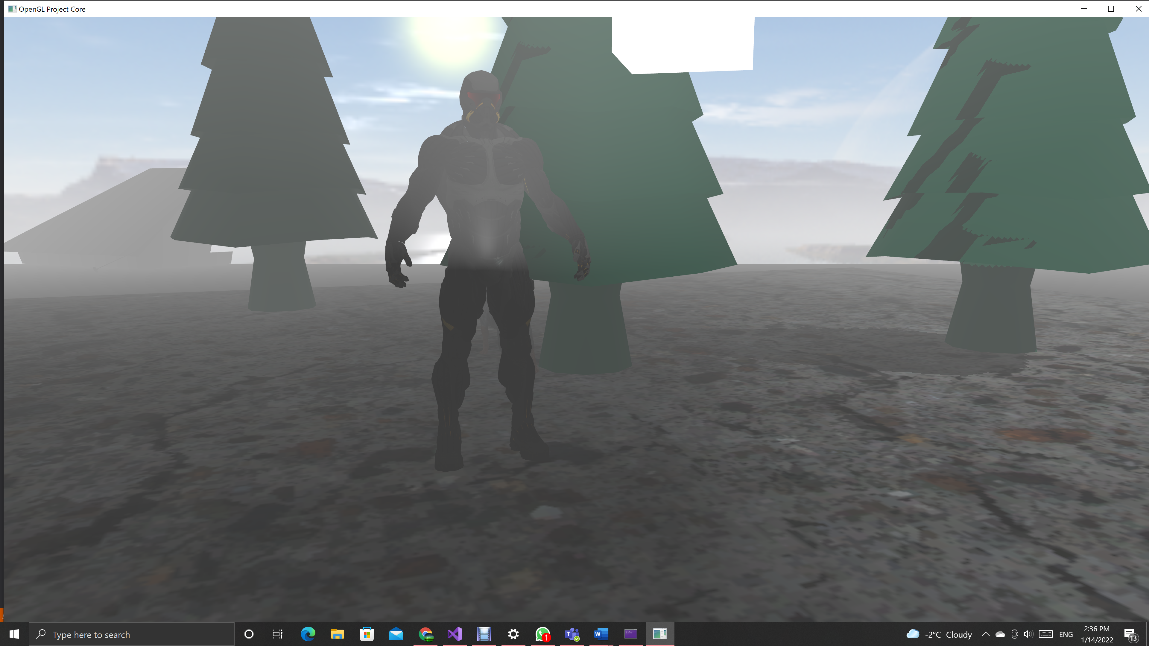

Directional lights influence the cast a shadow on the trees and on the ground.

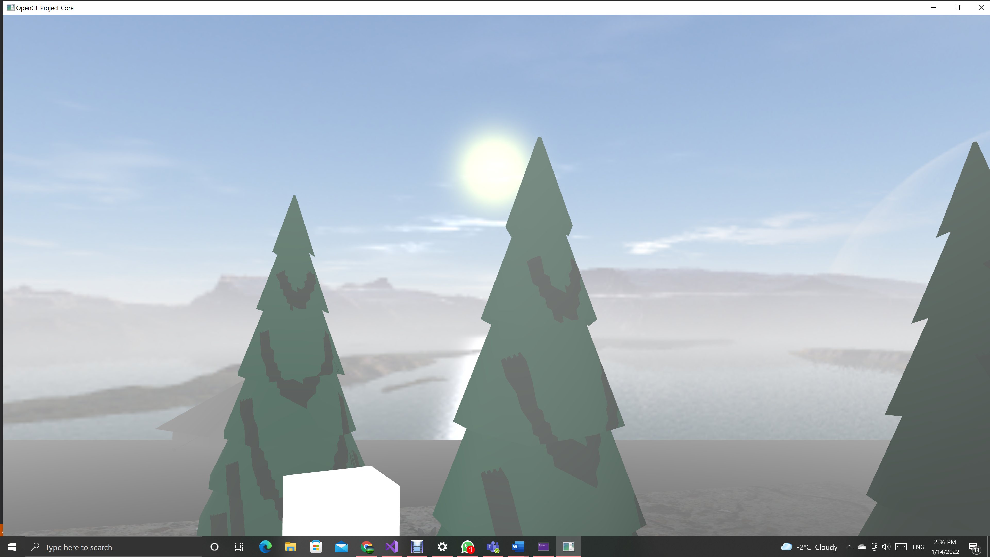

4) Implementation details

Some important functions of the project are presented below:

* processMovement(): handles the user’s inputs
* mouseCallback(): gets the cursor positions, computes how much it moved and changes the rotates the camera.
* drawObjects(): positions the objects in the scene, calls the “Draw” method.
* initModels(): Loads the files with our models.
* initFBO(): creates a framebuffer object to store the depth texture, for shadows.
* initUniforms(): sets values in the shader.
* renderScene(): renders the scene from the point of view of the user and light source.

This approach was chosen because it was simple, easy to understand from the laboratory works.

As graphic models I used .obj and .mtl files from the laboratory resources and from this link: <https://free3d.com/3d-models/>. Using the Blender I positioned, scaled and rotated these objects in the scene.

The data structure modified is the camera class. More vectors were added to fully describe the camera position and orientation.

Class hierarchy

Camera: movement logic and camera parameters.

Shader: methods for working with the shader

Model3D: methos for working with 3D objects.

5) Graphical user interface presentation / user manual

* W: move forward
* S: move backward
* A: move right
* D: move left
* I: look up
* K: look down
* J: look left
* L: look right
* N: rotate directional lights
* M: light point of view
* Z: normal view
* X: wireframe view
* C: point view

6) Conclusions and further developments

It was very satisfying for me to know some answers in how a virtual world is build and the brilliant methods that make a virtual world look more like the real world.

7) References

Labs, Udemy tutorials, Learn openGL page.